GCPS-R scoring:
The scoring algorithm for the GCPS-R is explained in Figure 2. Persons reporting no pain or pain on some days on Item 1 (i.e., pain not present on most days or every day) are placed at Grade 0—chronic pain absent. NOTE: Some persons with pain that may be bothersome (due to high PEG score) or have high impact (due to answer of Q2), but who do not report chronic pain because of Q1, may be still included in Grade 0.
Figure 2:
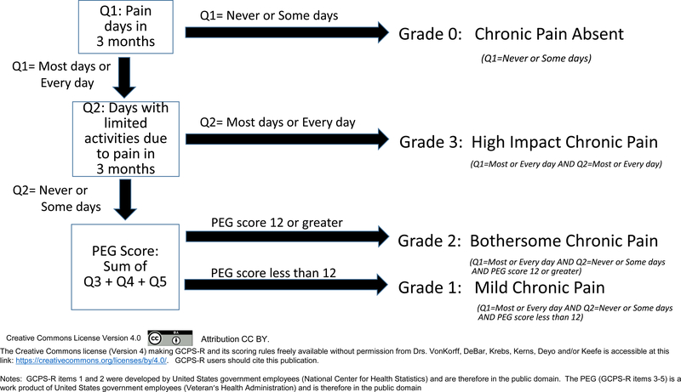
Open in a new tab
Chronic pain grade scoring rules for Graded Chronic Pain Scale – Revised
Persons with chronic pain are placed at Grades 1, 2 or 3. Among persons with chronic pain, those who report that pain limits their life activities or work on most days or every day in the past 3 months (Item 2) are placed at Grade 3 (High impact chronic pain). Among the remaining persons with chronic pain, the PEG score is determined by adding Q3+Q4+Q5. Those with a PEG total score of 12 or greater are placed at Grade 2 (Bothersome chronic pain). Those with chronic pain that is not high impact and whose PEG score is less than 12 are placed at Grade 1 (Mild chronic pain).
Thus the test gives 2 results:
PEG score—indicating severity of recent pain total of q3,q4 and q5, range of 0-30, and Average PEG score = Total/3, range 0-10
-GCPS-R score—as noted above 0-3

